21|11

Multi-Tasking
It is a process of executing multiple tasks simultaneously.
It can be achieved by two ways
- Multi-Processing
- Multi-Threading
Multi-Processing
It is the ability of a system to run multiple process simultaneously.
Process- Each process has an address in memory making it heavy way.
Multi-Threading
- It is a feature of java that allows concurrent execution of two or more parts of a program to maximize CPU utilization.
- Each part of such a program is called as thread and these threads run independently while sharing resources like memory.
- A Thread is a light weight sub process, the smallest unit of execution.
Benefits of multi-threading
- Efficient CPU utilization.
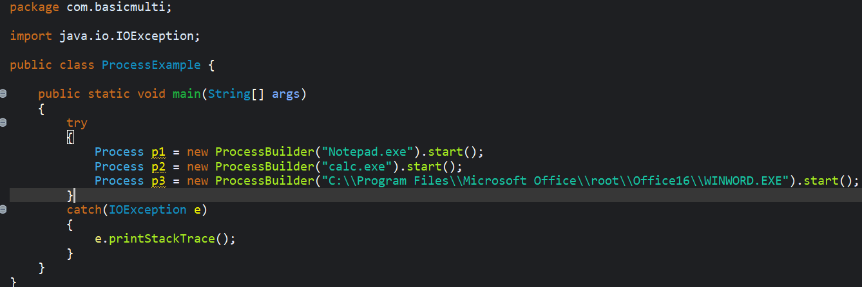
- Asynchronized Execution.

There are two ways to create Thread:
- Extending Thread class
- Implementing Runnable Interface

Life Cycle of a Thread
- New Stage: Thread object is created but not started.
- Runnable Stage: When start method called, the thread is ready to run but is waiting for CPU time.
- Running Stage: The Thread is executing the run method.
- Blocked/Waiting Stage: In this stage the thread is waiting for the resources.
- Terminated Stage: This state occurs when the thread has finished its execution or stops.
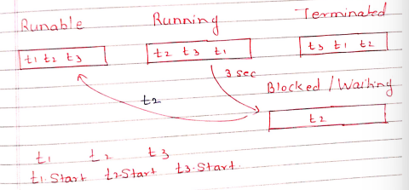
c c c
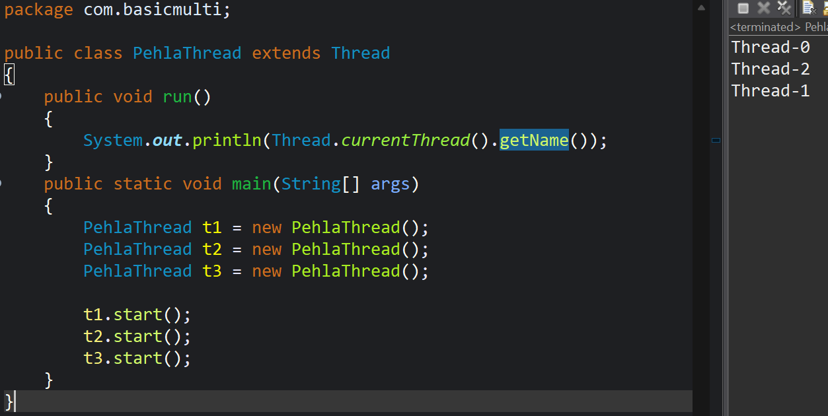
22|11
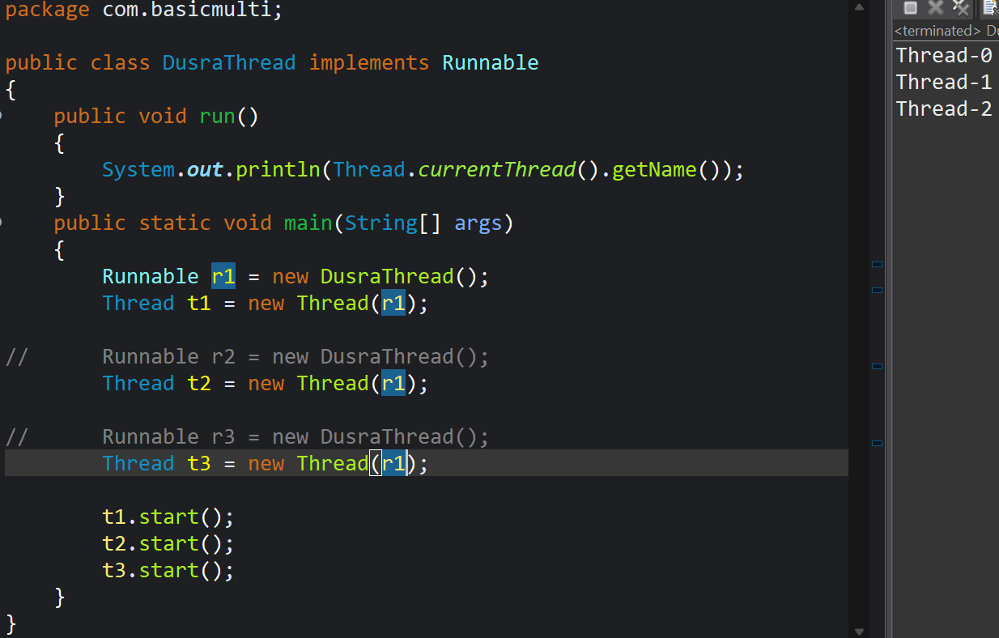
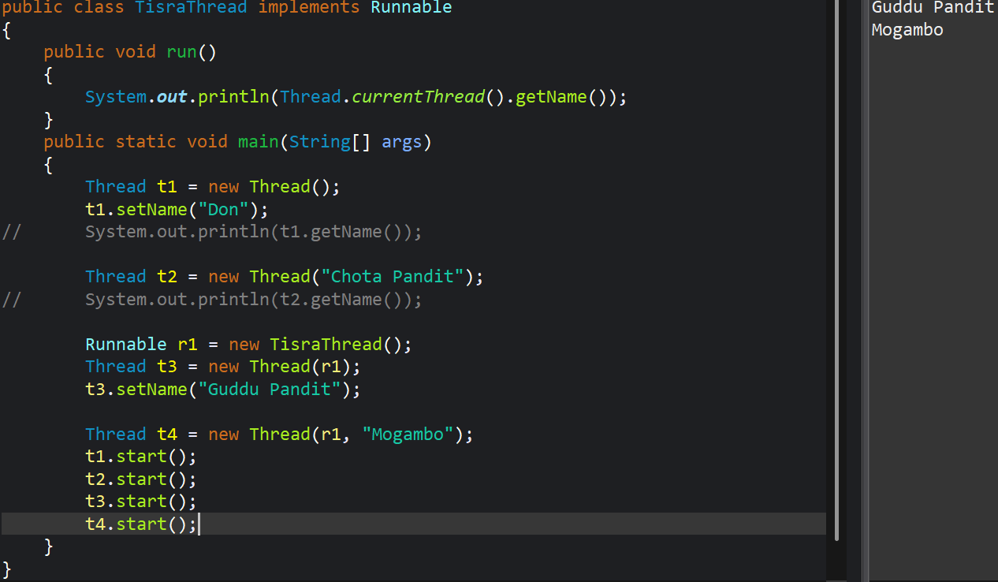
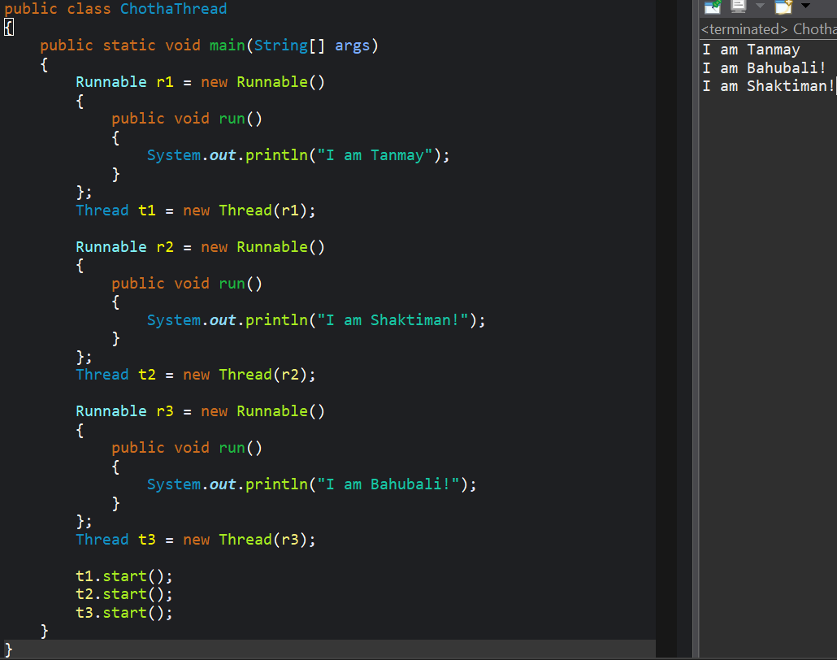
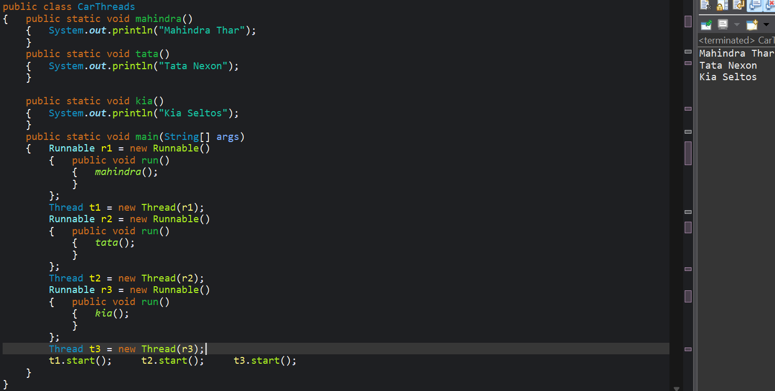
Thread Scheduler:
- The Thread Scheduler is part of the JVM that manages the execution of multiple threads based on priority and availability of system resources.
- It determines which thread should run, when to pause a thread and when to resume its execution.
Scheduling Techniques:
- First come first out
- Round Robin
- Priority Scheduler
- Shortest Job First
- Multi-Level Scheduling
Java thread Scheduling is primarily pre-emptive and priority based.
It’s like a mix of round robin and priority scheduler, with this schedular giving performance to higher priority thread but also ensuring that other thread get some time.
- Primitive Scheduling- The highest priority thread gets CPU time.
- Time Slice (Round Robin)- Threads get a fix time to execute, and then control moves to the next thread.
Note: However, java does not guarantee which scheduling policy will be used, as it depends on the underlying operating systems thread schedular.

sleep() method
- The sleep() method is a static method of a thread class.
- It used to pause the currently executing thread for a specify amount of time.
- sleep() method can throw an interrupted Exception.
- These Exception is thrown if another thread intercepts the sleeping thread hence, we must handle the exception in try and catch block.
25|11
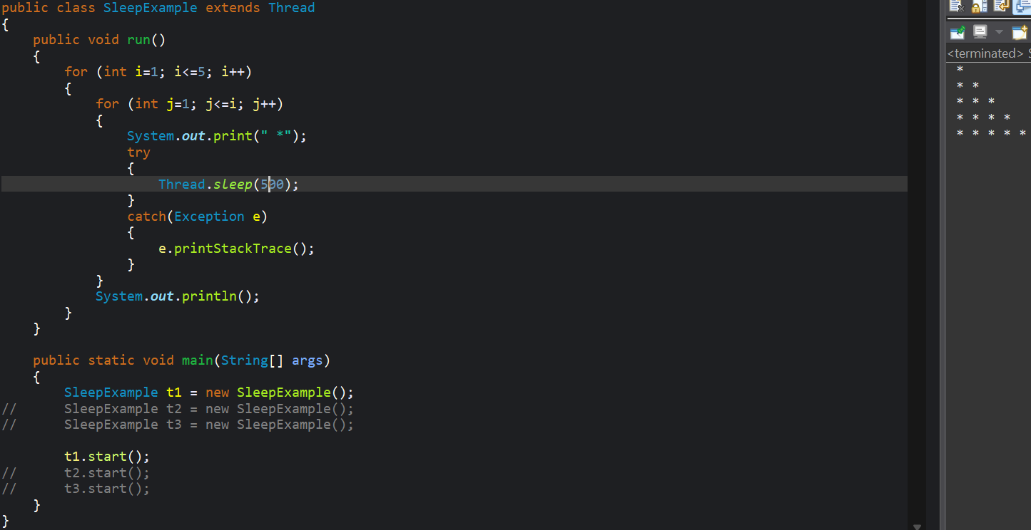

join() method
- join() method is used to make one thread wait for another thread to complete its execution.
- It’s a way to synchronized or co-ordinate the execution of multiple threads.
- join() can also throw an Interrupted Exception, If the waiting thread is Interrupted.
- It is an instance method.
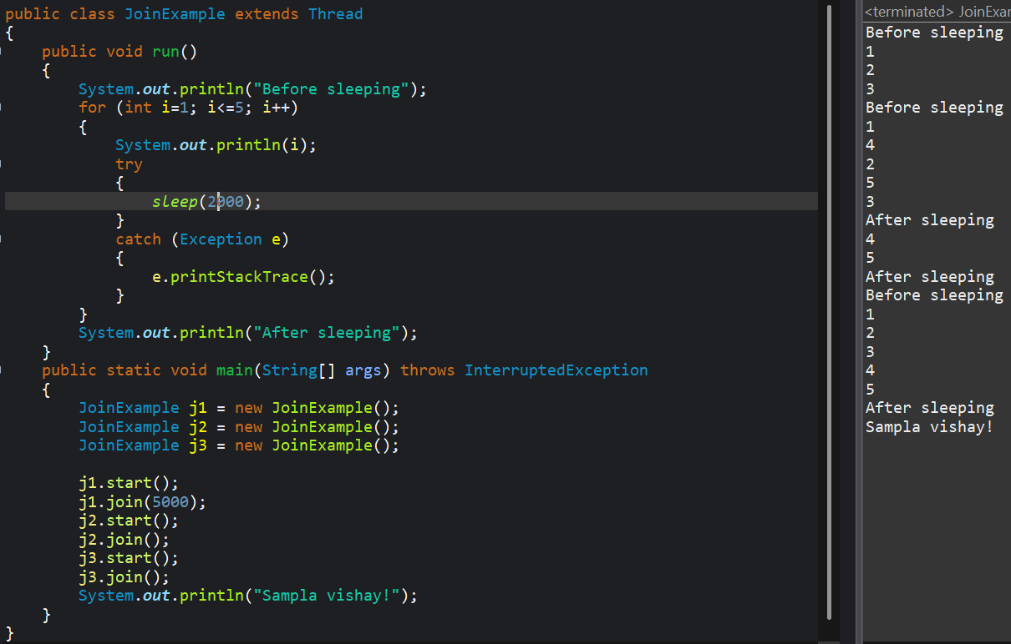
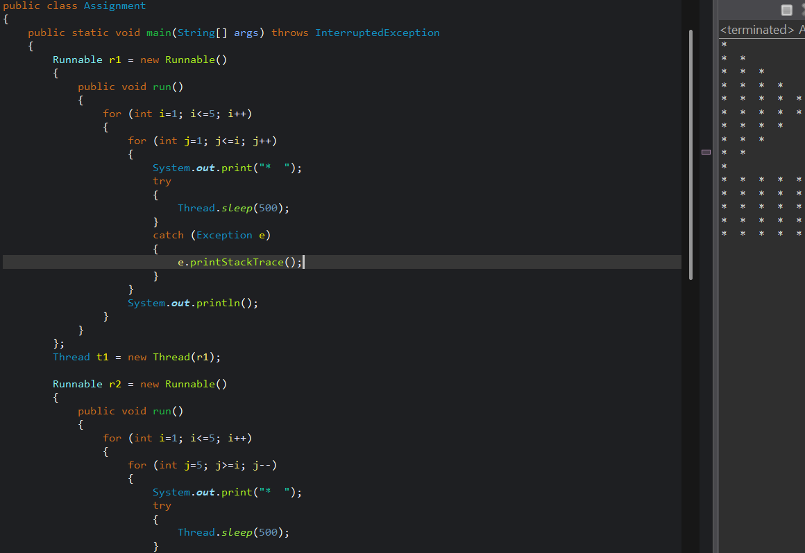
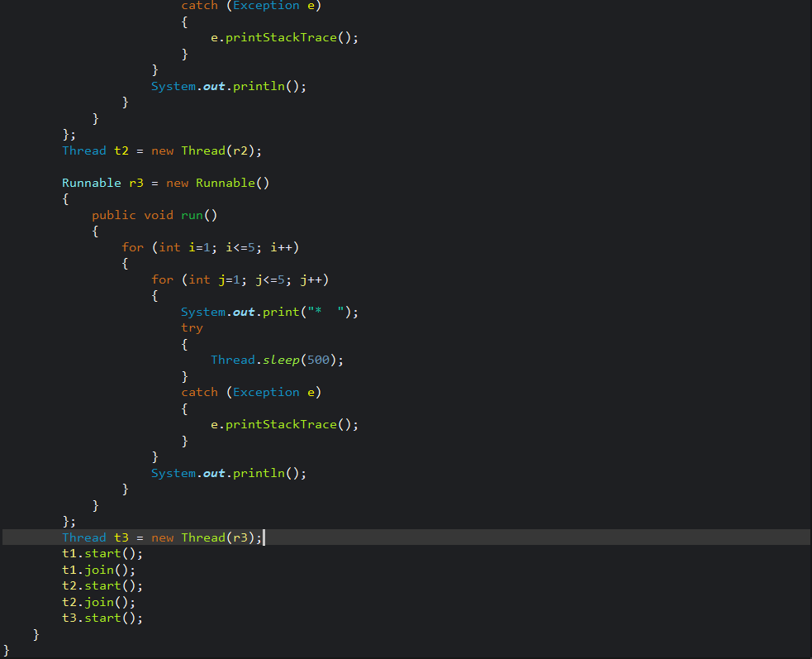
26|11
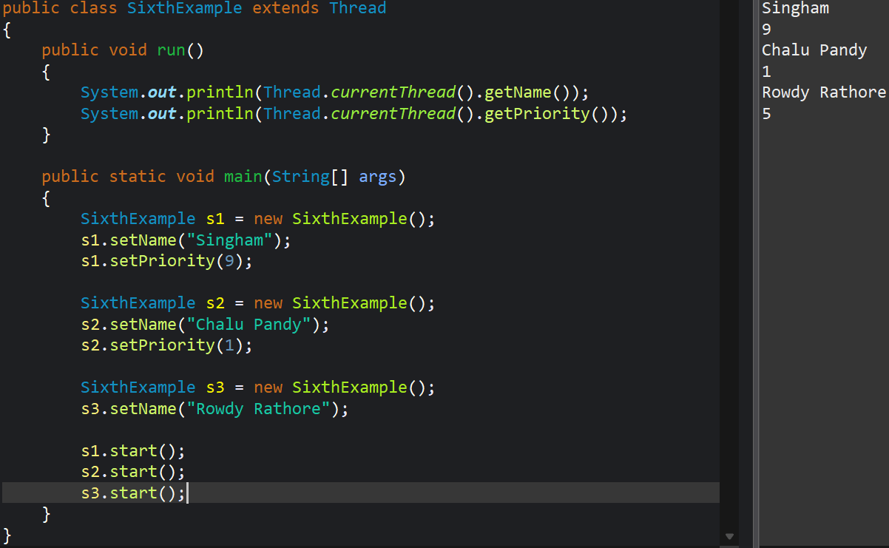
Two types of Thread
- User Thread.
- Daemen Thread.
A Daemen Thread is a low priority thread that runs in the background to perform task such has garbage collection or provide services to user thread.
The life of a Daemen thread depend on the mercy of user thread meaning that when all-user thread finishes its execution, the JVM automatically terminate the Daemen thread.
Some basic examples of Daemen Thread are
- Garbage Collector- reclaim the memory from where garbage is cleaned.
- Finalizer- cleans the objects which is not require for garbage collection.
- Event Dispatcher- It is mostly use in java swings.
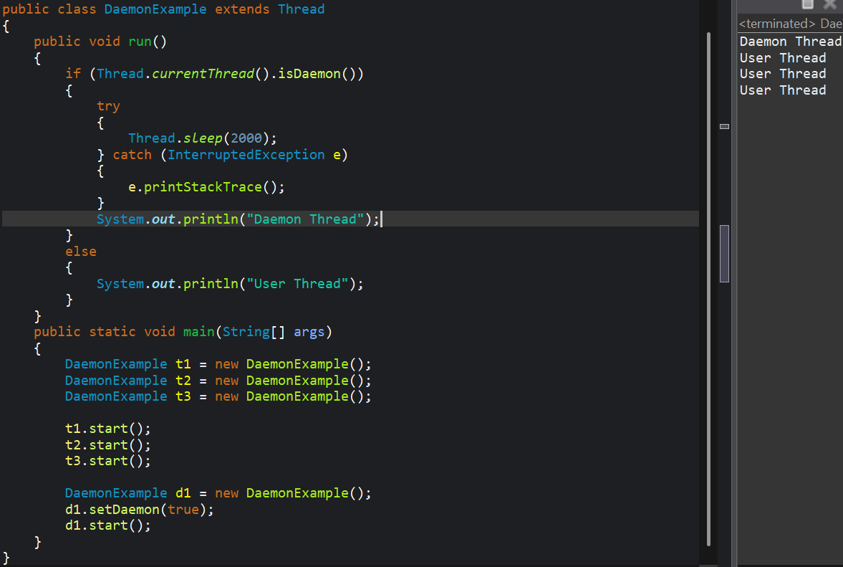

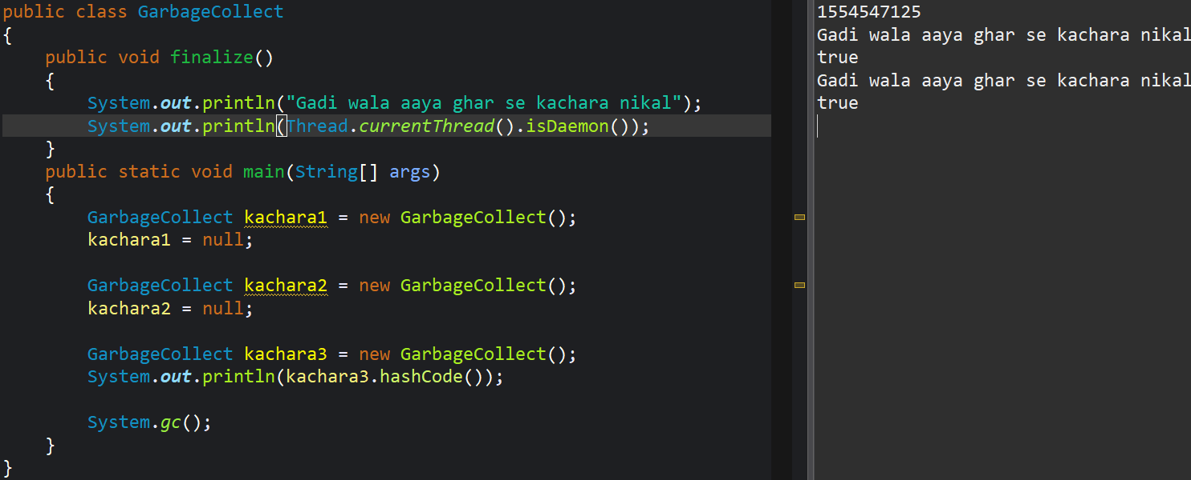
27|11
Synchronization in java is the mechanism that insures only one thread can access a shared resources at a time.
It helps prevent raised conditions and maintains data consistency when multiple threads try to modify shared data concurrently.

Types of Synchronization
- Instance Synchronized method.
- Static Synchronized method.
- Synchronized block.

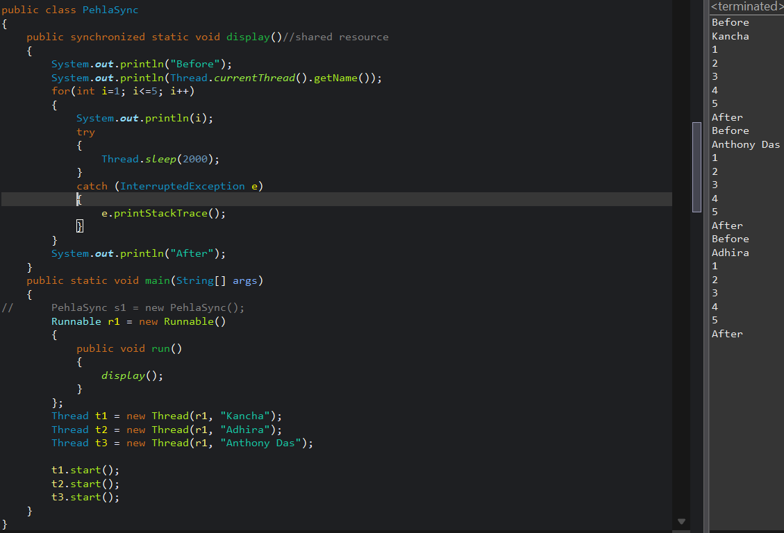

28|11
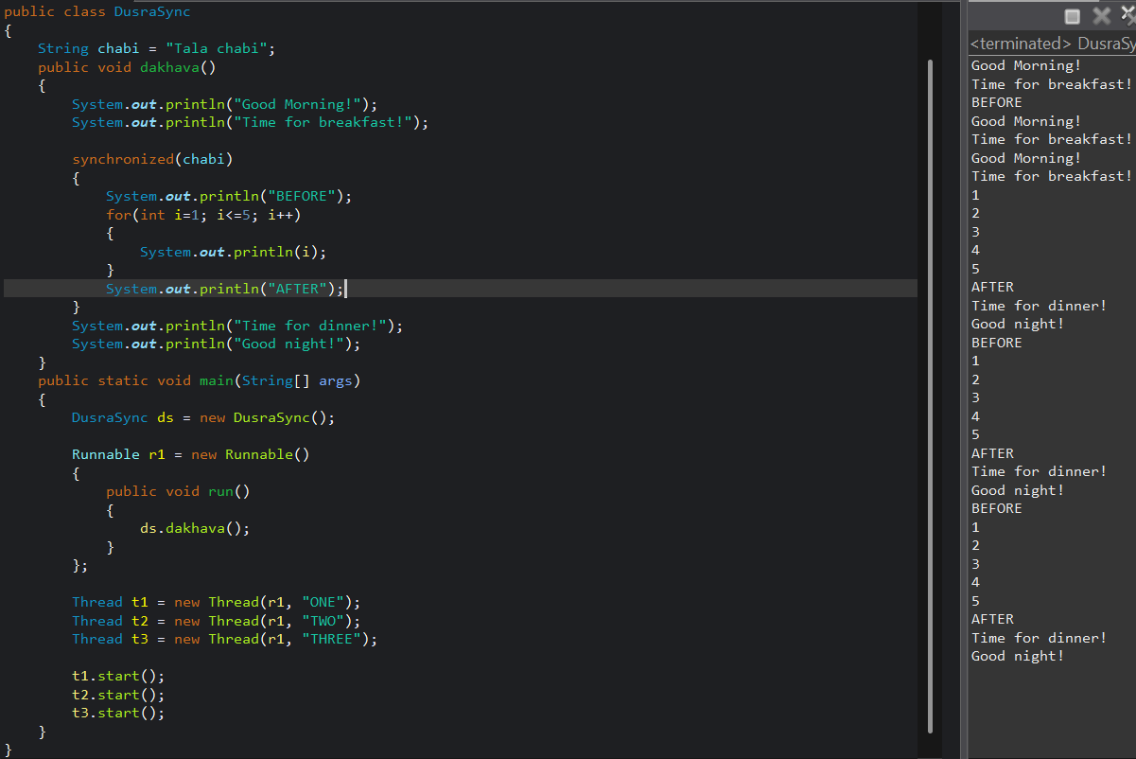
Intrinsic Lock:
- It is also called as monitor lock.
- It is built in lock for every java object.
- It is used by the java Synchronization mechanism to control access to code blocks or method so that only one thread can execute block or method at a time.
Dead Lock
A dead lock occurs when two or more threads don’t release the locks for other to execute it.
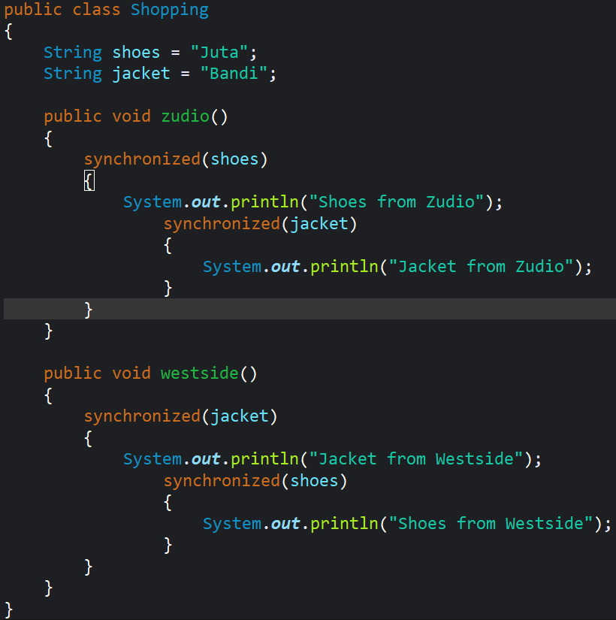
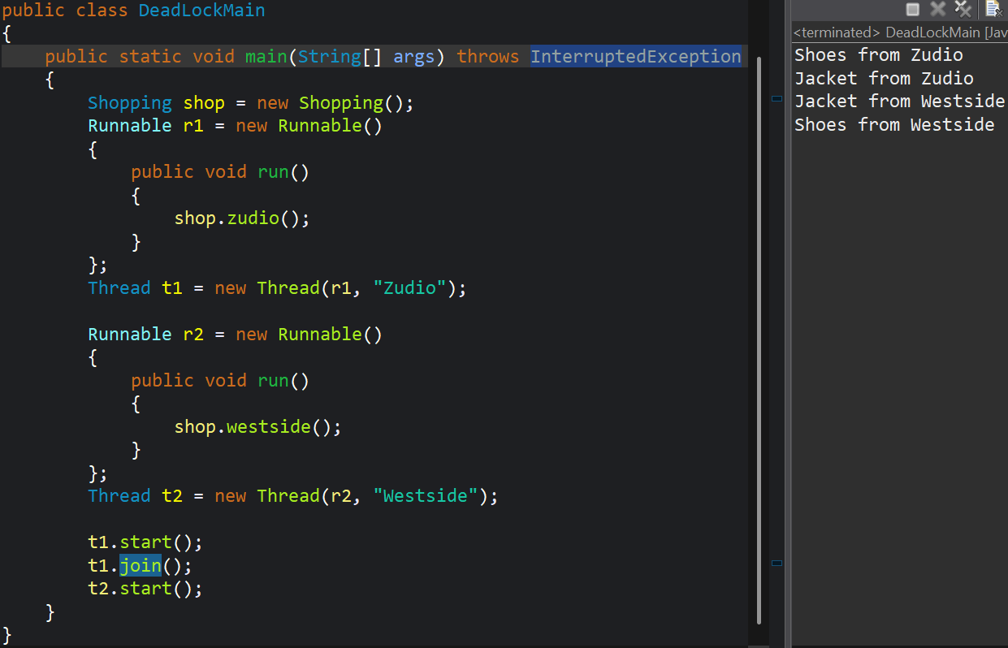
1|12
Inter Thread Communication
Inter Thread Communication refers to mechanism by which multiple threads communicate and co-ordinate with each other while executing concurrently.
It is essential when multiple threads shared resources and need to synchronized their actions.
To achieved inter thread communication we need wait(), notify(), notifyAll() method of object class.
These methods allow threads to communicate using a shared object monitor lock.
- wait()- It causes the current thread to release the lock and wait until another thread calls notify() or notifyAll().
- notify() It wakes up a single thread that is waiting on the objects monitor lock.
- notifyAll() It wakes up all the waiting threads.

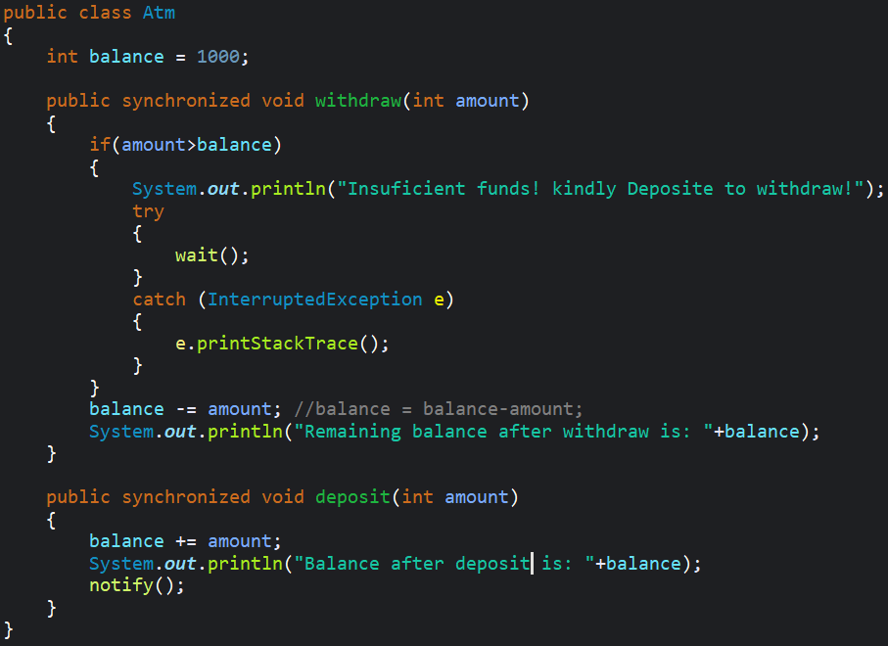
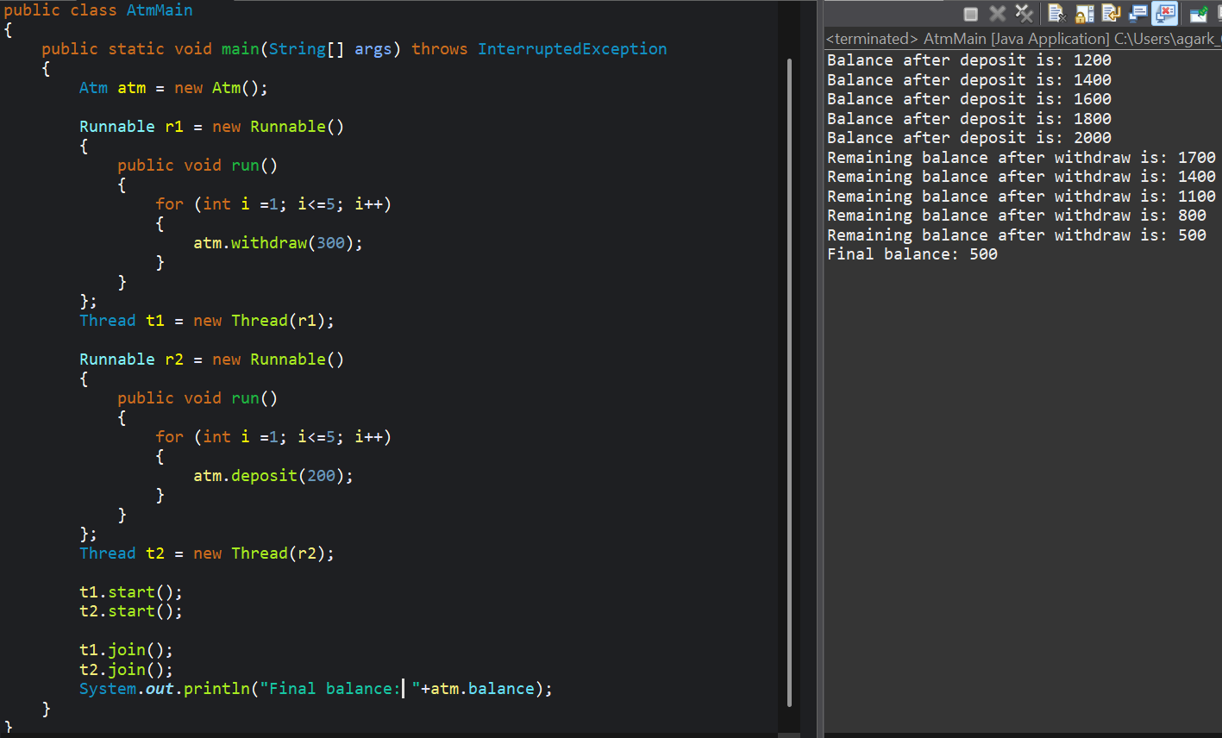

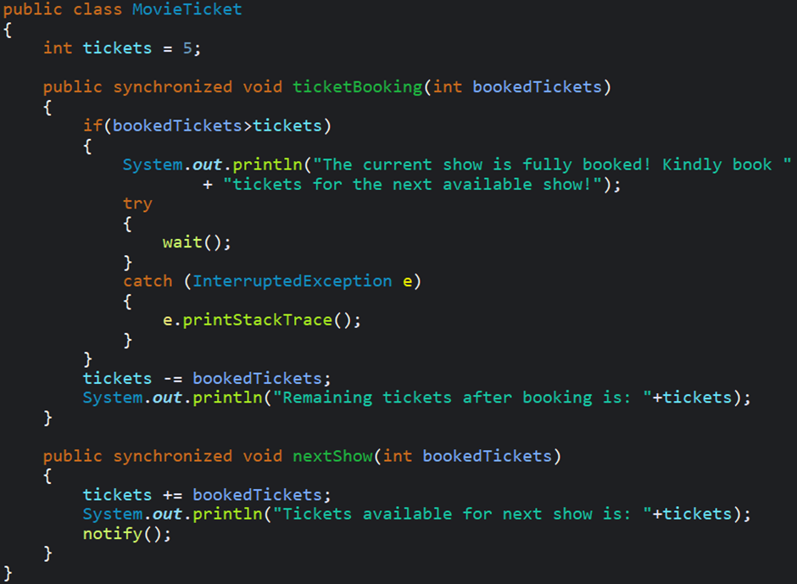
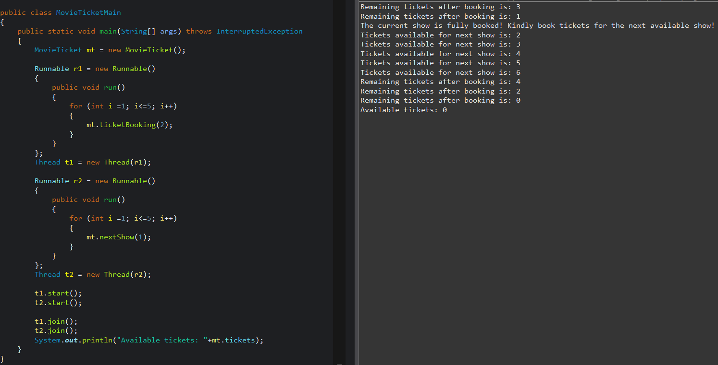

IMP
- What is multi-threading?
- Explain life cycle of Thread
- What is Thread Scheduler? Which techniques does it implement.
- Demonstrate the use of sleep() and Join() method
- What are the types of thread Explain each one of them
- What are the Types of Synchronization
- What is Inter Thread Communication
- which methods are used to communicate
- Difference between wait() and join()

